OG Web.site Unit 4 Assessment 5 Evidence Collection
Rob Johnston | OG Web.site evidence collection
Learner | Rob Johnston
Brand / document style | OG Web.site
Qualification | TQUK Level 3 Certificate in AI Programming with Python
Unit | Unit 4 - Linear Algebra Essentials for Deep Learning
Assessment | Deep Learning Training, Validation Tuning and Inference
Criteria covered: 3.1, 3.2, 3.3
All visuals in this document are actual output files generated by the Python project scripts in this assessment folder.
Reference | Screenshot / output | Annotation
3.1 Training run | 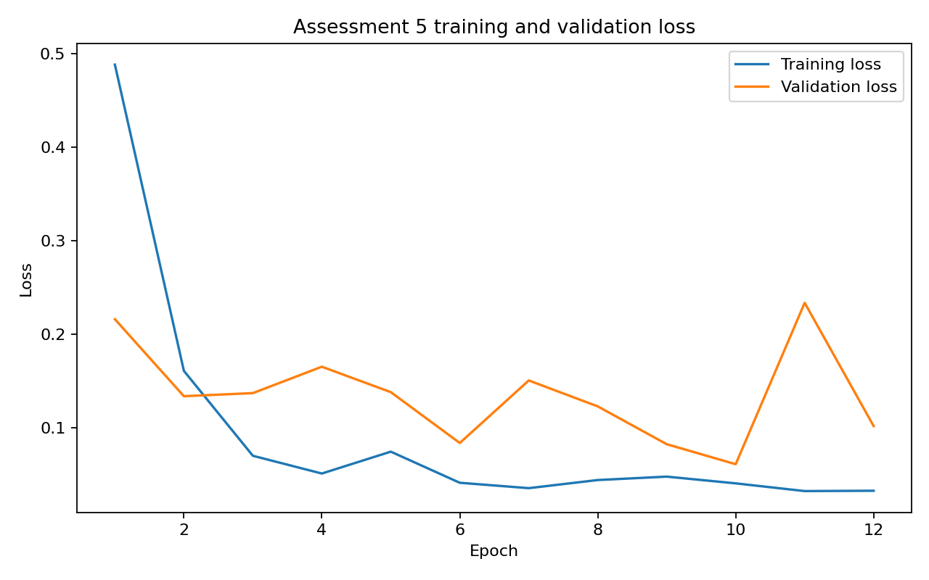 | Shows the model training process across epochs. The chart compares training loss and validation loss from the best hyperparameter configuration.
3.2 Validation set and hyperparameter tuning | See project files listed in annotation. | The script tested hidden_size/learning_rate configurations and selected the best model using lowest validation loss. Best validation loss: 0.0613. Test accuracy: 100.00%.
3.3 Inference and testing | 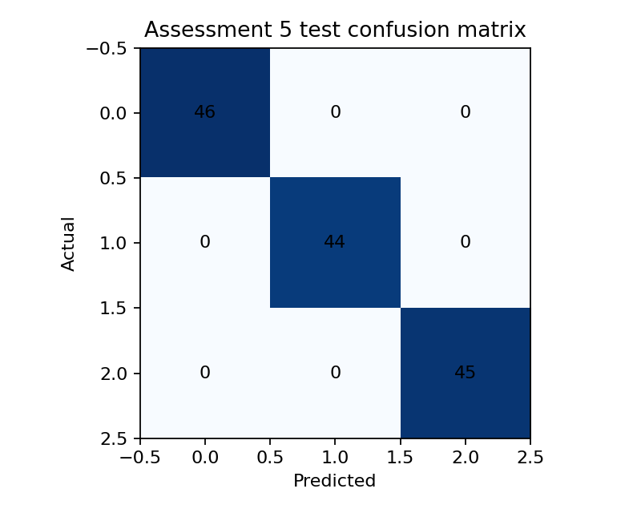 | The trained checkpoint was loaded and used for inference. The summary JSON records actual class 1 and predicted class 1 for the held-back example.
Project files | See project files listed in annotation. | Script: assessment5_train_validate_infer.py. Outputs: checkpoint, training metrics CSV, summary JSON, training/validation chart and confusion matrix.

